Curriculum Overview for EYFS Autumn 2018
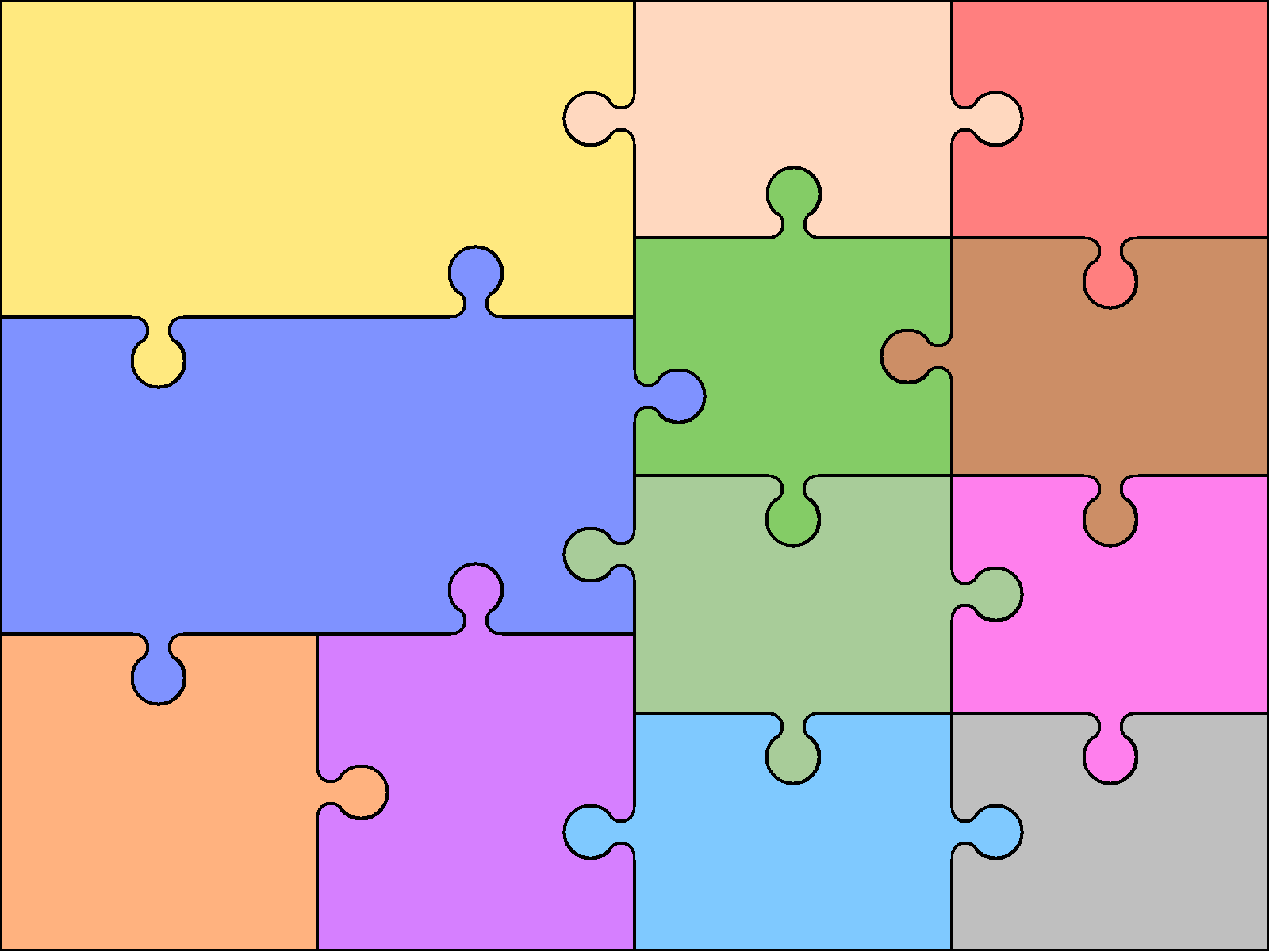  - Knows print carries meaning.  - Listens to and joins in with stories and poems – recognise rhyme.  - Can talk about familiar stories  - Hold books right way and turns pages.  - Begin to recognise and remember Speed sounds 1,  - Hear and say initial sounds in words.  - Write own name and other simple words.  - Begin to use Fred fingers to sound out simple words with known letters. | English/Literacy  - Can continue a rhyming string  - Can segment and blend sounds together to make words.  - Willing to have a go at writing captions and labels and talk about own work.  - Knows the difference between fiction and non-fiction books.  - Beginning to recognise some common High Frequency words. |  | Books to be used  - The shopping basket  - Granny Baggy  - The enormous crocodile  - Books by Julia Donaldson  - Books by Roald Dahl  - Traditional tales | Expressive Arts & Design Exploring and using media and materials  - Paint - mix colours, create moods, name  Primary and secondary colours.  - Use a range of paints, powder, thick, water colours, pastels, chalk  - Printing – sponges, shapes, natural objects.  - Clay - rolling, squeezing, shaping, joining  - Drawing – trying different pencils  - Collage – Using a wide variety of media to create different effects | Textiles – use a variety of different fabrics for textures, simple sewing stiches and decorating.  Weaving – using many different materials, and fabrics.
 |  |  |  | - Malleable materials.  - Working with tools  - Joining and building  - Model making | Being Imaginative  Acting out stories  Using small world and role play to recreate experiences  Expressing own ideas, thoughts and feelings through, music,art, dance and storytelling.  Role play areas to be a home, a shop  Dressing up
- Count, read, recognise numbers to 20 and beyond.  - Use number names and language.  - Grouping objects by colour, shape, size, quantity.  - Make and continue a given pattern  - Select given numbers of objects  - Find one more than, one less than a given number.  - Count reliably from 1 – 20 place numbers in order  - Estimate a group of objects, use the language more and fewer to compare.  - Compare length, weight.  - Recognise and name simple shapes. | Mathematics  Join two groups of objects by adding.  - Find the total of two groups of objects.  - Own choice of recording.  - Familiar with 2D & 3D shapes and know some properties. |  | - Begin to write numbers for recording.  - Solve simple number problems with explanations.
 |  |  |  | Forest School Skills  - Lighting fires  - Using tools, drill, bow saw, tent pegs, fire strikers, hammers and nails.  - Simple cooking over the fire.  - Making dens  - Using natural materials to create works of art. | - Performing: To use voices expressively and creatively by singing songs an speaking chants and rhymes. To play tuned and unturned instruments musically  - Composing: To experiment with, create, select and combine sounds using voices, instruments and sound effects.  - Appraising: To listen with concentration and understanding to a range of music
Understanding the World  People and Communities  Know about their own families and significant events that happen.  Know about family customs and traditions and understand that all families are different.  Learn about other cultures in the world.  Find out and explore Shipley and Southwater.  The World  Know about their own immediate environment and how environments can be different, hot and cold countries.  Observe the changing seasons. |  | Recognise plants, leaves, birds  and trees.  Care for creatures found in environment.  Aware of changes happening and why.  Techonology  Use simple programs on the computer.  Be familiar with the keyboard and key features of a computer.  Program a simple moving toy.  Know that a range of technology is used everyday.
 |  |  |  | Physical  Education  - Circle games  - Multiskills with a variety of balls.  - Dance  - Simple gymnastics, making body shapes. Changing shape and direction., simple sequences  - Obstacle course and routes | Religious Education  - Why is the Bible a very important book?  - What are some of the stories in the Bible  - What can we learn from the Bible.

