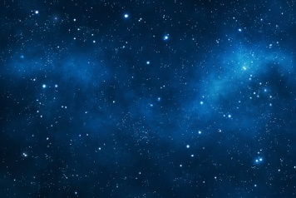  Research the constellations – maybe you would like to find the one for your birth star sign – and create a piece of artwork based on it. | Read a space themed book and write a book review about it.  Would you recommend it?  Who might like to read it?  Is it fiction or non-fiction?  What is the plot?/What information does it contain?
Pretend you are an astronaut and write a diary entry about your day? What have you been doing? How do you feel about it? | 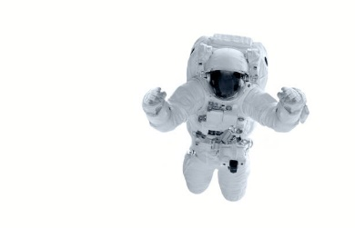  Research a famous astronaut and create a leaflet, fact file or powerpoint presentation about them, sharing details and information about them and what they have done.
Design your own planet. What would it be like? Would it be searing hot or covered in ice and snow? Would it have seas or jungles? What colours would the sky be? Would any alien or plant life be able to survive there?  You could draw and label it or even create a 3D model!  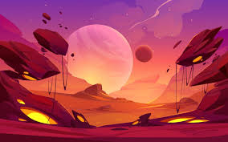 | Join the NASA kids club where you can play games and find lots of other different space themed activities to do:  https://www.nasa.gov/kidsclub/index.html
HOME LEARNING TASKS – SPACE

These activities can be completed at any time during the term and brought in to class to share with us all. As always, if you have your own ideas for a space themed activity we would be delighted to hear all about them. We really look forward to seeing what you have chosen to do!

