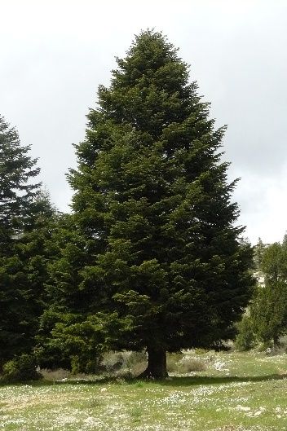
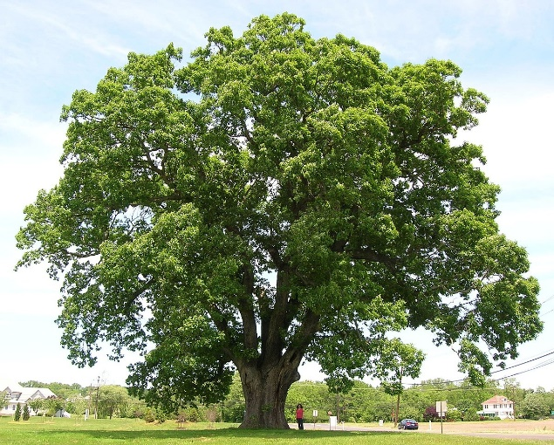
Oaks Science and Understanding of the World
Week 12 – 13-07-20

Welcome to our last Science lesson of the Year. Well done for keeping going with the tasks. It’s been such fun finding different ways of learning through this Summer. I’ve been really impressed with the efforts you have made. Thank you.
This week is the last part of our plants topic. We are going to look at the different parts of the trees and plants and create a big tree using material. Another slash lesson of Science/Art/DT. There will even be a bit of measuring so /maths too. Here are our key words: seed, bean, water, warmth, nutrients, leaves, stem, roots
If you can collect some or all of these plants. You are going to cut them up and look closely at them.
carrots with roots and leaves, lettuce, celery, red cabbage, daffodils, tulips, lillies, geraniums, tomatoes, courgettes

What is the name of each plant?

What do you think is inside?

Ask an adult to help you cut the plants and flowers in half so you can see what’s inside.
- Look at the roots – these help to anchor the plant into the ground and absorb nutrients and water for the plant
- Look at the stem – this is like its backbone, helping to keep it strong and give support in the wind so it doesn’t blow away – it forms a tube to send nutrients and water upwards to the leaves and the flowers
- Look at the leaves – these help to feed the plant by collecting the sunlight and turning it into food

Look closely at the patterns inside. What do they look like? What shapes can you see?
Now use your sketch book or some paper and carefully draw, colour, paint, pastel or sketch the patterns you see. Make them the right colours and make them fill the paper. Draw the shapes you see.
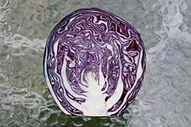
When you have finished your Science Artworks. Use a ruler and label the parts of your plants. Tell me what you have learnt about the different plants and what each part of the plant does. Use your adjectives to describe and your nouns for the parts of the plants. Maybe you could use some verbs to tell me how the parts of the plants would move.
Take a picture and send it in. I would love to see what you do.

The last part of our plants is about trees. Here are our key words for this part.
plant, leaf, grow, deciduous, evergreen, roots, stem, leaves, flower, trunk, bark
Look at the trees you can see in your garden or when you are out on your walk or cycle. Are the trees evergreen or deciduous? Do you know their names?
Take some wax crayons and do some rubbings on the bark, branches and leaves.

Do they lose their leaves in the winter? Can you remember?

Do they stay green all year round?

If we don't know, can we guess by looking at the shape of their leaves?

On the class page is the resource sheet for this lesson. It tells you about the different sorts of trees and has a tree measuring challenge. Take a look and have a go.

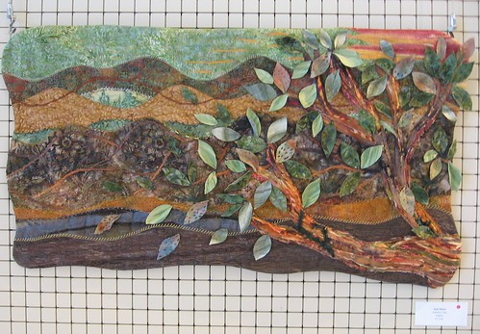
Finally, find as many different materials as you can. Bits of old materials, old t-shirts, t towels, towels, sheets – anything you have and make a giant tree in the garden. Take a picture and send it in. I will use these as displays in the classrooms.
You could make two. A deciduous one and an evergreen one. Have fun and well done everyone.

