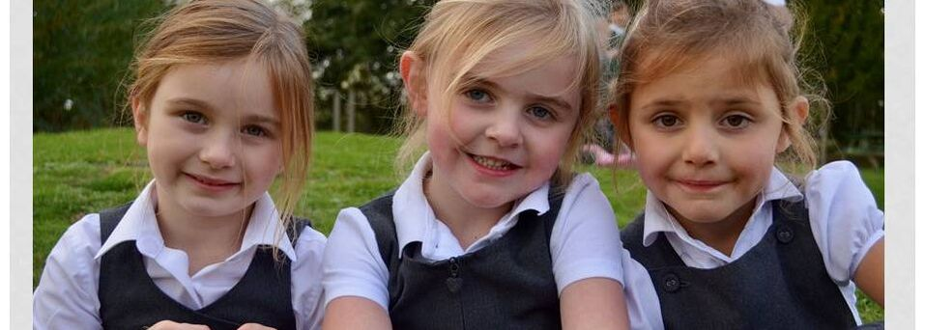
Parent Handbook

Taking you step-by-step through starting school

Shipley Church of England
Primary School
Friendship, Faith, Future
Welcome to Shipley Church of England Primary School and we are looking forward to welcoming your child to our school.

The shared understanding of the school’s vision of Friendship, Faith and Future effectively underpins daily school life.

ADMISSION ARRANGEMENTS
On starting school in Reception, parents can decide whether their child starts on a full-time or part-time basis. The statutory school age remains the term following the child’s fifth birthday, which is when the child must be receiving full-time education. Parents still have the right to defer entry.

STAFF AT SHIPLEY SCHOOL

Headteacher & SENCO Mrs Jen Harvey
Sycamores Class Teacher Ms Emma Stas
Ash Class Teachers Mrs Lorna Jessop/Mrs Susie Fuller
Oaks Class Teacher Ms Lynsey Barker
Willow Class Teacher Mrs Gill Simpson
I.T. Teacher Mrs Sue Upstone
Teacher Mrs Glyn Davies
Teaching Assistants Mrs Joanne Gorton
Mrs Judith Petros
Ms Joanna Berry
Mrs Sharon Dodd
Bursar Mrs Sally Grimes
Secretary/Clerk to the Governors Mrs Jill Phillips
Midday Meals Supervisor Mrs Denise Aldridge
Mrs Rita Johnson
Premises Manager Mr Rob Lewis

Term Dates are as follows for 2023/2024

Autumn Term 2023
Inset Days: Friday 1st September & Monday 4th September
Start: Tuesday 5th September
Half Term: Monday 23rd October – Friday 27th October
Ends: Friday 15th December

Spring Term 2024
Starts: Tuesday 22nd January
Half Term: 12th – 16th February
Ends: Thursday 28th March

Summer Term 2024
Starts: Tuesday 15th April
Bank Holiday: Monday 6th May
Half Term: 27th May – 31st May
Ends: Tuesday 23rd July

What are School Times?
Start of School 8:40 am (Gates open at 8:30 am)
Morning break 10:30 am
Lunch break 12:00 noon – 1:00 pm
End of School 3:05 PM

Parking
Please be mindful of residents’ access at pick up and drop off times.

Child Protection and Safeguarding
The welfare of our pupils is of paramount importance. We listen to our pupils and take seriously what they tell us. All staff have a duty of care and a collective responsibility for safeguarding. Any concerns about children are reported to the designated Child Protection staff, who are trained to deal with them and work alongside or refer to other agencies if necessary. There is a clear policy on Safeguarding and Child Protection, which is available on our website.

School Attendance
At Shipley CE Primary School, we have high expectations of attendance from all pupils. Regular attendance is essential to ensure children reach their potential both academically and socially. Pupils with good attendance records generally achieve higher grades and enjoy school more. Please ensure that your children are in school on time. Children who are late sometime worry which makes a poor start to the school day.
Illness
If you suspect your child is unwell, do not send them to school. Please inform us by telephone or email before 9:00 am on each day of your child’s absence. Children must always remain absent from school for a full 48 hours after any illness that includes vomiting and/or diarrhoea.
Medical Appointment
If an absence relates to a medial appointment, the school request sight of the appointment letter but wherever possible these appointments should be arranged
outside school hours.

Holidays
Head Teachers cannot authorise absence for holidays in term time unless there are exceptional circumstances. It should be remembered that this is a Government led directive. Children are required to attend school for 38 weeks each year, leaving 14 weeks to attend family holidays.
Request for Absence
If you are considering leave within term time, please ask the School Office for a Request Form which must be completed and returned, the form will then be forwarded to the Headteacher.

Uniform
A list of uniform required for school is attached along with a price list and our school supplier is Taylor Made Uniforms www.taylormadeuniforms.co.uk

Food in School
Shipley was one of the first primary school in West Sussex to offer locally produced hot boxed school meals. The hot lunches include a main course ad pudding. The ingredients are locally sourced and freshly cooked by “The Easy Lunch Company” based less than two miles from the school. More information can be found on the company’s website: www.theeasylunchcompany.co.uk

Free School Lunches
Free school meals are available for all children in Reception, Year 1 and Year 2 (Universal Infant Free School Meals). Older children whose parents receive Income Support are also entitled to free meals.
Break-time and Drinks
All Reception, Year 1 and Year 2 have a morning snack of fresh fruit or vegetables. We encourage children to drink water regularly during the day. Children should bring a bottle of water each day. All of our under-fives are entitled to free milk.

Charging Policy
School Trips
When organising school trips, the school may invite parents to contribute to the cost of the trip. All contributions are voluntary. If we do not receive sufficient voluntary contributions, it may be necessary to either subsidise or cancel a trip.
Support for Parents
Parents who receive state benefits or free school meals can request support from school to cover the cost of educational visits; this is always dealt with in the strictest of confidence.

Health and Welfare
Health
It is absolutely essential for the school to know of any relevant medical facts relating to your child, e.g. allergies, asthma, eczema, diabetes or epilepsy. Please keep the school regularly updated with relevant medial information so that appropriate provision can be made for each child.
Medicines
Medicines will only be administered at school when it would be detrimental to a child’s health or school attendance not to so do. Parents will be required to complete the appropriate authorisation form, which is available from the office. The medication has to be labelled correctly by the Pharmacy and provided in the original container with the instructions and information leaflet.

Parent’s Evening
We hold Parents’ Evenings throughout the year when we meet with you on a more formal basis to discuss your child’s progress and keep you informed about the school curriculum.

School Reports We provide all parents with an annual written report from the class teacher at the end of the summer term, which provides information about your child’s academic achievement and summarises their personal and social development.

News
We send out a weekly Newsletter to all parents by email, which gives out lots of
information, updates, term dates, our activities and upcoming events. All newsletters
can also be found on our website www.shipleyceprimary.com.

Outdoor Leasrning
All children access timetabled outdoor learning. The school has two dedicated outdoor learning areas in the grounds. Children learn how to grow plans, create shelters, light a fire, use tools, sculpt, work as team and gain a health respect for the outdoors. Conservation work is an integral part of this learning. The garden and pond area are also cared for by the children.

Wraparound Care
Breakfast Club /Early Bird Club
We open from 8:00 am in the morning to allow you to drop off your child safe in the knowledge that they will be eased gently into the day ahead and given breakfast. The cost of this is £3 per day per child (limited number of spaces)
After School Clubs
After school clubs run from 3:05 pm – 4:00 pm. The choices of clubs to attend is sent out at the end of each term ready for the following term. These clubs can include Art, Sport, Lego and Film and Homework. We also run Windmills Club some afternoons, which run from 4:00 pm – 5:00 pm. There will be a charge for these.

Governance
We have a full and active Governing Body, which includes parent governors as well as representatives from staff and the local community. The Governors have a range of duties and powers and a general responsibility for the conduct of the school with a view to promoting high standards of educational achievement, managing the school’s finances, making sure the curriculum is balanced and broadly based. To find out who are Governors are please refer to our website.

Parent Teachers Association
Shipley has a very active PTA known as FOSS (Friends of Shipley School) and everyone in the school community is automatically a Friend of Shipley School. They organise many events for the children helping to raise funds for the school. They are always looking for volunteers to assist them. If you are interested then contact the school office and they will forward your name on to the Chairperson.

We need some information from you
Attached are a number of forms that need to be completed and then returned to the School Office.

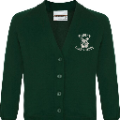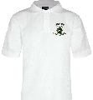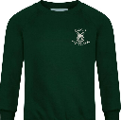
Uniform
We are proud of our collective sense of belonging and correct uniform is a strong element of this.

Winter
Dark grey shorts or trousers
Grey skirt/grey trousers or grey pinafore
White short of blouse
Dark green sweatshirt/cardigan
Pain grey black or white socks or dark green tights
Plain black school shoes

Summer
Dark green shorts or trousers
Green and white striped dress (optional)
White polo shirt
Plain sandals that protect toes

PE
Shoes: Indoors – black plimsolls - Outdoors – Trainers
Green school shorts and green T-Shirt
Sweatshirt/hoodie and/or grey/green tracksuit
PE bag (from school office)

Additional Items
Forest School Kit
Summer sun hat
Painting apron or shirt
Wellington boots – needed often
Book bag (from school office)

School uniform standards extend to jewellery, nail varnish and hair. There should be no nail varnish and no jewellery (other than a small, inexpensive watch or small stud earrings). Long hair should be tied back neatly with no oversized or bright accessories. No extreme styles or colours are permitted; this includes shaved patterns or logos.

Shipley School sweatshirts, polo shirts, hoodies, fleeces, waterproof jackets and PE kit are available from www.taylormadeuniforms.co.uk

Please ensure all items are named a checked regularly. The school cannot accept any responsibility for personal clothing and possessions that are lost.

